**Math 120**

**Test 1C**

**Student Name: _______________________________________ Student Number: ______________________**

**Directions:**

* SHOW ALL YOUR WORK OR JUSTIFICATION FOR ANSWERS *ON THE TEST*. Scrap paper is sometimes hard to read and I want to give you partial credit!
* Simplify all answers.
* Round answers as indicated.
* Include units with final answers.

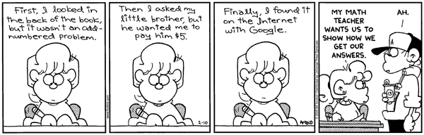

* 1. Decide whether each of the following statements makes sense (is clearly true) or does not make sense (is clearly false). Fill in the right side of the table in each line with *True* for makes sense or with *False* for does not make sense.

|  |  |
| --- | --- |
| **Statement** | **True (makes sense) or False (does not make sense)** |
| The slope of a vertical line is 0. |  |
| The Difference Quotient is used to find the slope between any 2 points of a function. |  |
| To find the zeroes (y-intercept) of a function, you find f(0). |  |
| In an inverse relationship, the domain and range interchange. |  |
| $f\left(x\right)=6x+7$ is a linear function and has a domain of . |  |

* 1. Determine if the following are functions. Answer YES or NO in the blank. (5 points)

1.  __________________
2. {(5,2), (7, 9), (5, 9), (3, 0)} __________________
3. x=12 __________________

1.  __________________
2. 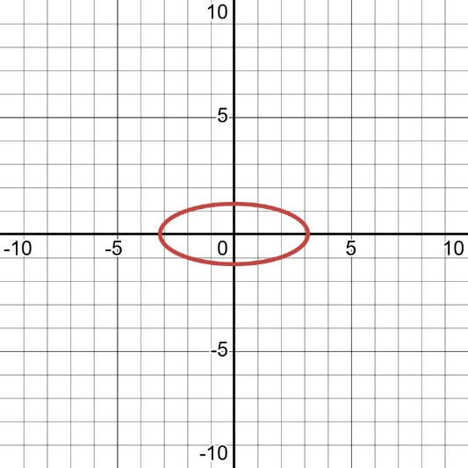 __________________

3. Use the graph below to find the following. (5 points)

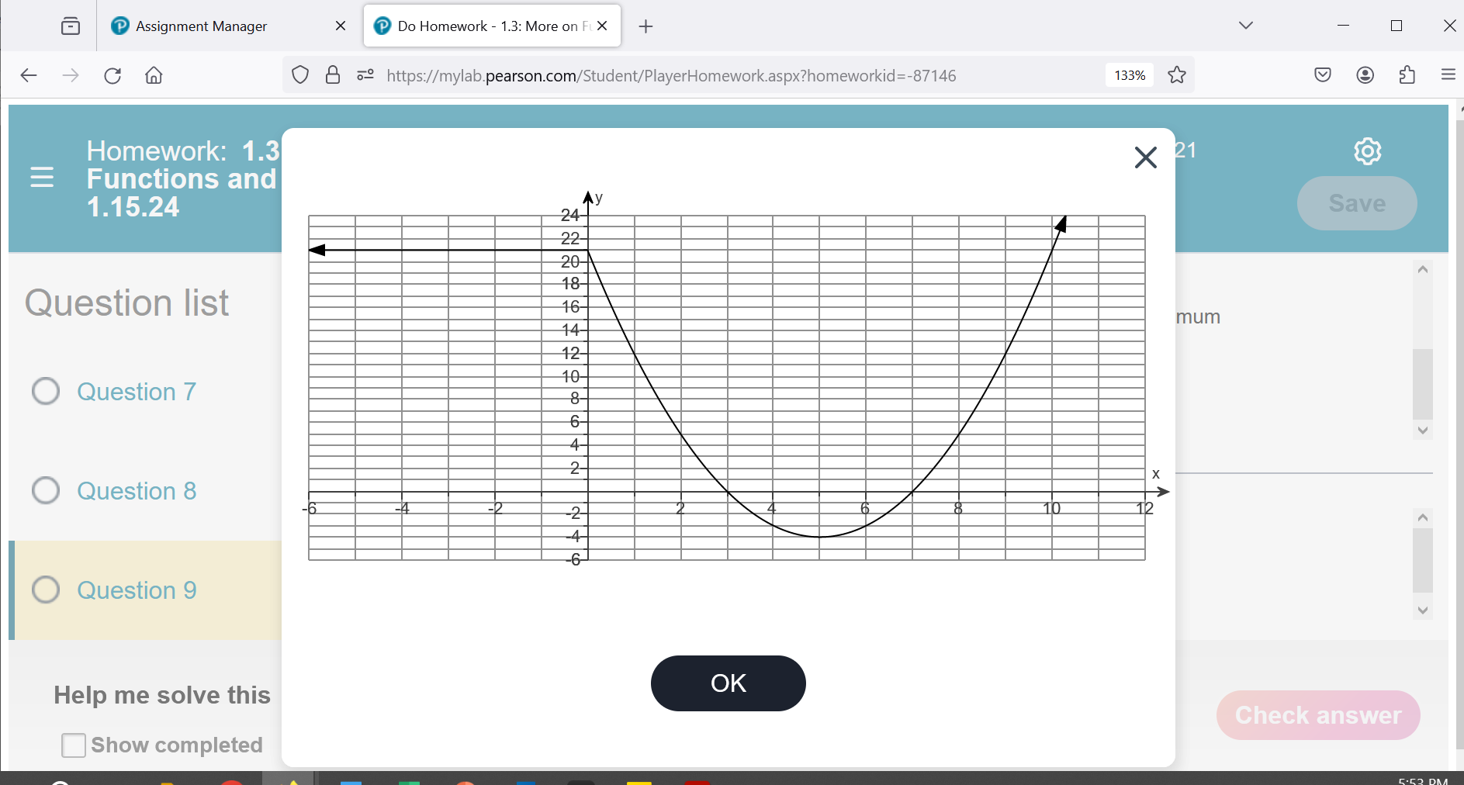

a. List the x-intercept(s), if any. If there aren’t any, say NONE. a.______________________

b. List the y-intercept(s), if any. If there aren’t any, say NONE. b.______________________

c. Find  c.______________________

d. For what value(s) of x is  d.______________________

e. State the domain in interval notation. e.______________________

4. Use the graph above to find the following. (5 points)

f. State the range in interval notation. f.______________________

g. State the interval(s) on which *f* is increasing g.______________________

h. State the interval(s) on which *f* is decreasing h.______________________

j. The number where *f* has a relative minimum j._______________________

k. What is the relative minimum of *f*? k.______________________

5. a. A limited-edition *Attack on Titan* anime Blu-ray box set was released for $600. Due to declining demand, its resale value has decreased by $30 per year. Write a function that describes the value of the box set, *V,* after *x* years. (3 points)

a.______________________

b. In how many years will the box set be worth $390? (2 points) b.______________________

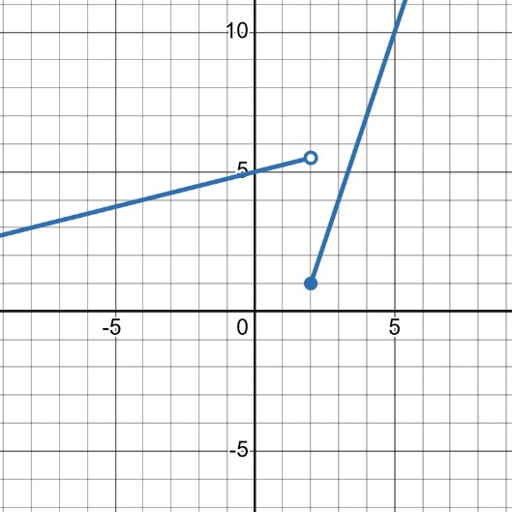6. Use the piecewise function shown. (5 points)



a. Find 

__________________

b. Find 

__________________

7. Consider the function: $f\left(x\right)=-4x+3$

a. What is the slope? (2 points) a.______________________

b. Construct and simplify the **difference quotient**. (3 points) b.______________________

8. Find the equation of the line that goes through the point (8, -2) and has a slope of $-\frac{1}{4}$. Put your final answer in slope-intercept form. (5 points)

______________________

9. Use the graph.

a. Select any two points on the graph and find the slope. (2 points)

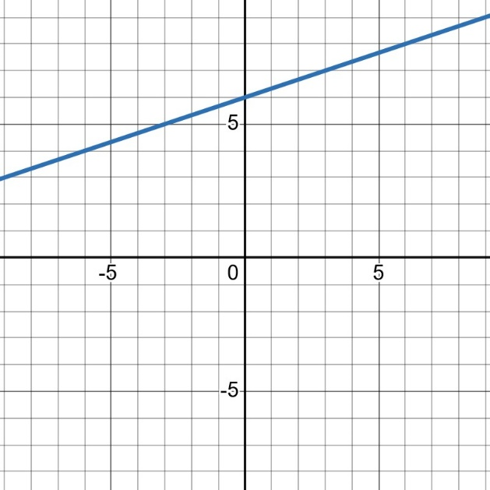

______________________

b. Construct the equation for this graph. (3 points)

Put your final answer in slope-intercept form.

______________________

10. Refer to the figure below.

a. Find the slope between the two points given. Simplify and round to the nearest hundredth. Include units. (3 points)

(82,27)

(74,16.5)

______________________

b. Interpret the slope in the context of the problem including units. Answer in at least one complete sentence. (2 points)

________________________________________________________________________________________________________________________________________________________________________________________________________________________________________________________________________________________________________________________________________________

11. Find the equation of a line that is parallel to the line and passes through the

point (-8, 10). Put your final answer in slope-intercept form. (5 points)

______________________

12. Find the equation of a line that passes through the point (3,7) and the slope is undefined. (5 points)

______________________

13. Use the data set below related to baking, focusing on the relationship between oven temperature and the baking time for cookies.

a. Use the two points whose coordinates are shown by the balloons to find the equation of the line that models the baking time, f(x), as it pertains to the oven temperature, x. Use function notation. Put your final answer in slope-intercept form. (3 points)

a.____________________________

b. Use the linear function you made above to predict the baking time when the over temperature is set to 275°F. Include units. (2 points)

b.____________________________

14. Suppose that a ball is hit off a tennis racket up in the air and then comes back down to the ground. The height of the ball above the ground as a function of time is given by the equation:  where  is the height of the ball in meters and *t* is the time in seconds.

* 1. What is the height of the ball above the ground after t=1 seconds? Include units and do not round the answer. (1 point)

a.______________________

b. What is the height of the ball above the ground after t=2 seconds? Include units and do not round the answer. (1 point)

b.______________________

c. Using the information you found in part *a* and *b*, find the AVERAGE RATE OF CHANGE between t1=1 second and t2= 2 seconds. Include units and do not round the answer. (2 points)

c.______________________

d. Interpret the average rate of change in the context of the problem including units. Answer in at least one complete sentence. (1 points)

________________________________________________________________________________________________________________________________________________________________________________________________________________________________________________________________________________________________________________________________________________

15. Find the domain of the given function. Write your answer in interval notation. (5 points)



______________________

16. Find the domain of the given function. Write your answer in interval notation. (5 points)



______________________

17. Given  and 

a. Find  and simplify. (2 points)

a.______________________

b. Find  and simplify. (3 points)

b.______________________

18. Using the functions from the previous question, find the following:

a. Find . (2 points)

a.______________________

b. Find . (3 points)

b.______________________

19. Decompose the function that follows such that $h\left(x\right)=(f∘g)(x)$. Be sure to label which function is $f$ and which is $g$. (5 points) 

______________________

______________________

20. Consider the function that is one-to-one.

a. Find an equation for . (3 points)

a.______________________

b. Use interval notation to give the domain of . (2 points)

b.______________________

OPTIONAL EXTRA CREDIT QUESTION:

Construct and simplify the difference quotient for the following function:



______________________

**Formula Sheet: Math 120**

**Straight Line**

Slope Intercept form Point-slope form Slope

  

**Difference Quotient Quadratic Formula**

 

**Logarithms**

  

**Distance**:  **Midpoint**: 

**Circle**: 

**Quadratic Function**

, Vertex =  , Vertex = 

**Compound Interest**:  **Continuous Compound Interest:** 

**Arithmetic Sequence Geometric Sequence**

 Finite:  

 Infinite: , 

**Even function Odd function**

 